**Project Proposal: Timetable Management System - “Planify” by Red Mouse**

**Project Relevance**

Effective time management is essential in both professional and educational environments. With increasing complexity in scheduling, a reliable timetable management system can streamline operations, reduce conflicts, and improve productivity. This project addresses the challenges of manual scheduling and inefficient management by offering an intuitive digital solution. It is especially relevant for organizations, educational institutions, and teams aiming to optimize their workflows.

Competitors such as Notion, Bitrix, and WEEEK dominate the market, yet our proposed system introduces specialized features tailored to enhance usability and flexibility for users requiring robust timetable solutions. These include synchronized calendars, CRUD functionalities for users, tables, and teams, and customizable table templates, distinguishing our solution in the competitive landscape.

**Analysis of Competitors**

* **Notion:** Renowned for its versatility and collaborative features, Notion offers extensive customization but lacks a dedicated timetable management focus, which can be overwhelming for users seeking straightforward solutions.  
    
  A screenshot of a roadmap template

  Description automatically generated
* **Bitrix:** Provides comprehensive business management tools, including task management and calendars, but its complexity and steep learning curve deter smaller organizations or individuals.  
    
  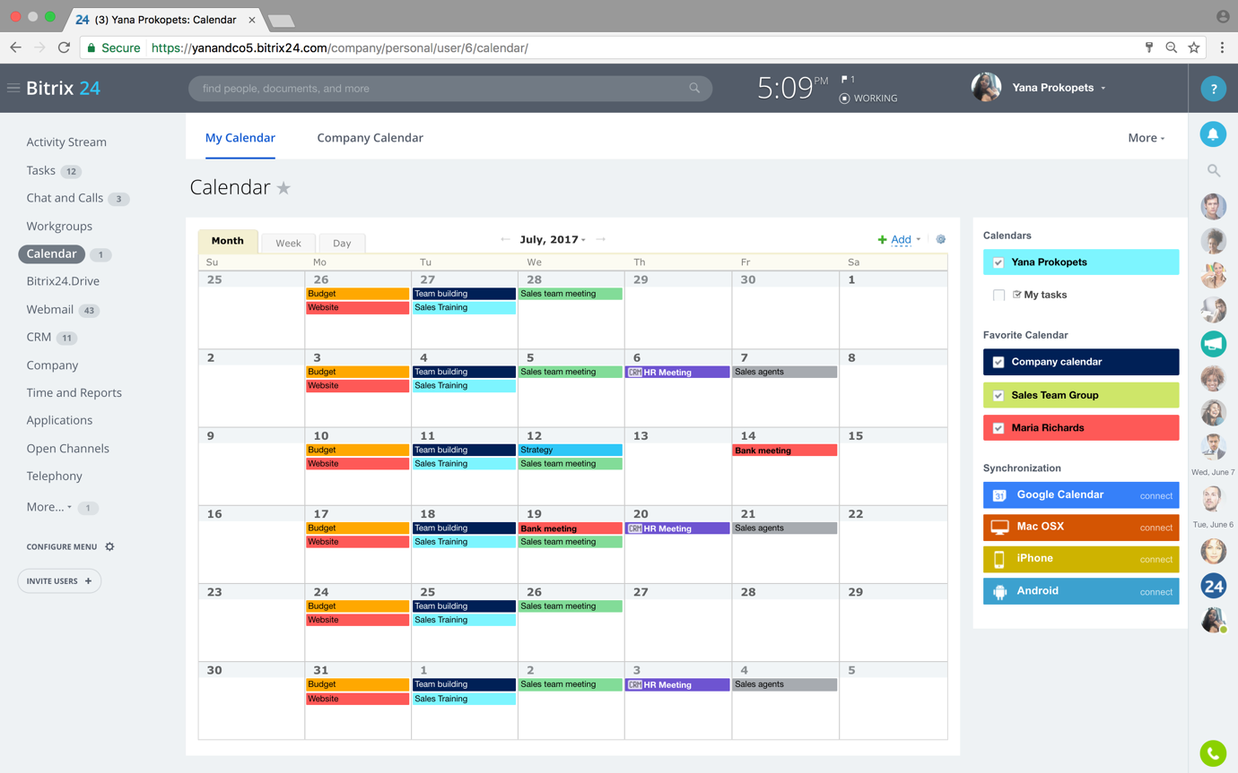
* **WEEEK:** Focused on task and project management, WEEEK offers a user-friendly interface but does not specialize in timetable-specific functionalities.  
    
  A screenshot of a computer

  Description automatically generated

**How Our System Is Better:**

* **Focus on Timetable Management:** Unlike competitors that offer general tools, our system is dedicated to solving timetable-specific challenges.
* **User-Friendly Customization:** Intuitive table templates make scheduling easier and faster, which is a unique offering compared to the complex interfaces of competitors.
* **Real-Time Synchronization:** Our synchronized calendar ensures updates are instantly reflected across all devices, offering a seamless user experience.
* **Simplified Team Collaboration:** CRUD operations for teams allow smooth collaboration, a feature often buried or underdeveloped in competitors’ systems.

**Project Audience**

The primary audience for this system includes:

* **Educational Institutions:** Schools, colleges, and universities requiring automated scheduling solutions for classes, exams, and events.
* **Organizations:** Teams and departments needing streamlined scheduling for meetings, projects, and resource allocation.
* **Individuals:** Professionals managing personal and professional schedules who value synchronization and customization.

**Project Features**

**Core Functionalities:**

* **CRUD Operations for Users:** Create, read, update, and delete user profiles, ensuring user management.
* **CRUD Operations for Tables:** Manage tables effectively, allowing for flexible scheduling options.
* **CRUD Operations for Teams:** Add and manage teams seamlessly, catering to collaborative environments.

**Supplementary Features:**

* **Synchronized Calendar:** Ensure real-time updates and synchronization across devices and platforms.
* **Table Templates:** Provide pre-designed templates for common scheduling needs, saving time and enhancing usability.

**Technology Stack**

* **Frontend:** **React.js**, known for its efficiency and compatibility with GoLang backend systems.
* **Backend:** **GoLang with Fiber**, offering high performance and scalability. **Fiber** is a fast and minimalist web framework for Go, which will enable efficient routing, improved performance, and quick development of the backend API. Its lightweight nature is perfect for building high-performance applications, ensuring that the timetable management system can handle a large number of requests simultaneously without compromising speed.
* **Database:** **MongoDB with Atlas**, providing flexibility and seamless integration for handling complex timetable data. By leveraging **MongoDB Atlas**, the fully managed cloud service, we can ensure scalability, security, and automated backups. MongoDB’s document-based structure is well-suited to the evolving needs of timetable data, allowing for easy updates and complex querying, which is crucial for efficient timetable management.

**Development Plan**

* **Platform Development:** Design a user-friendly interface with intuitive navigation and functionality.
* **Database Collections:** Implement collections for:
  + **Users:** Store user data, roles, and preferences.
  + **Tables:** Manage scheduling data.
  + **Teams:** Facilitate collaboration and group management.
* **Integration and Testing:** Ensure seamless synchronization and robust functionality through rigorous testing.

**

**Week 1 (23.01.2025 – 19.02.2025)**

* On-Site Meetings (4 days) - Assigned to **Sayan** (Backend - GoLang)
* Discussions with Stakeholders (3 days)
* Stakeholder Requirements (1 day) - Assigned to **Chingis** (Frontend - React.js)
* Customer Requirements (1 day) - Assigned to **Nuraidyn** (Database - MongoDB)
* Document Current Process (8 days) - Assigned to **Sayan** (Backend - GoLang)
* Analysis Complete (2 days) - Assigned to **Chingis** (Frontend - React.js)

**Week 2 (20.02.2025 – 13.03.2025)**

* Design Database (4 days) - Assigned to **Nuraidyn** (Database - MongoDB)
* Software Design (5 days) - Assigned to **Sayan** (Backend - GoLang)
* Interface Design (2 days) - Assigned to **Chingis** (Frontend - React.js)
* Create Design Specifications (5 days) - Assigned to **Nuraidyn** (Database - MongoDB)
* Design Complete (1 day) - Assigned to **Sayan** (Backend - GoLang)

**Week 3 (24.02.2025 – 25.03.2025)**

* Deploy Development Environment (1 day) - Assigned to **Chingis** (Frontend - React.js)
* Develop System Modules (11 days) - Assigned to **Nuraidyn** (Database - MongoDB)
* Integrate System Modules (7 days) - Assigned to **Sayan** (Backend - GoLang)
* Perform Initial Testing (3 days) - Assigned to **Chingis** (Frontend - React.js)
* Development Complete (1 day) - Assigned to **Sayan** (Backend - GoLang)

**Week 4 (24.03.2025 – 15.04.2025)**

* Deploy Test Environment (1 day) - Assigned to **Chingis** (Frontend - React.js)
* Perform System Testing (8 days) - Assigned to **Nuraidyn** (Database - MongoDB)
* Document Issues Found (6 days) - Assigned to **Sayan** (Backend - GoLang)
* Bug Fixing
  + Bug 1 (1 day) - Assigned to **Chingis** (Frontend - React.js)
  + Bug 2 (1 day) - Assigned to **Nuraidyn** (Database - MongoDB)
  + Correct Issues Found (3 days) - Assigned to **Sayan** (Backend - GoLang)
* Testing Complete (1 day) - Assigned to **Chingis** (Frontend - React.js)

**Conclusion**

The proposed timetable management system bridges the gap between generic scheduling tools and the specific needs of users requiring efficient timetable management. By addressing market gaps and integrating key functionalities, this project offers a valuable solution for individuals and organizations alike.